Civilization 4 PTBS Walkthrough

What is PTBS?
Civilization 4 brings with it many exciting gameplay options. One of the most intriguing for the Multiplayer community as a group, is PTBS. Gone are the days where you are required to choose between a super-fast, “BLAZING FFA TINY MAP JOIN NOW!!!!!!” MP game, or a two-year hitch with a PBEM, with a 10% or less chance of actually finishing.

PTBS, or Persistent Turn Based Server (PiTBoSs for short!), allows a compromise between the two game modes. PTBS is, at its heart, a true Multiplayer mode, and in many ways is identical to playing a regular Multiplayer game that normally plays in real time in a few hours. It has nearly all of the options of MP available to it, including Simultaneous Turns, and if all of the players in the game are logged in at once, many turns can be played in quick sequence.

The difference with PTBS is that the game stays up even when no-one is connected to it. This allows players to connect to it individually to play their turns at their convenience, while still allowing a reasonably fast turn pace, allowing most games to be completed within a year (or even less!) even taking the full turn timer each turn (at 24 hour turns).

PTBS allows for the advantages of a PBEM – a small time commitment each day, greater opportunity for diplomacy, and the ability to play with people from around the world – while cutting down the time required to complete the game, and allowing for a simplified interface that does not require e-mailing turns or even knowing your opponent’s information.

How do I play PTBS?
Playing a PTBS game that is set up ahead of time, is as simple as connecting to a multiplayer game. You connect through the normal Civ4 interface.

First, determine if the PTBS game is set up in Gamespy or through the DirectIP interface. Your game host should inform you of this before starting the game.

If the game is in Gamespy (“Internet”):
First off, choose “Multiplayer” in the main menu, then choose “Internet Games”.
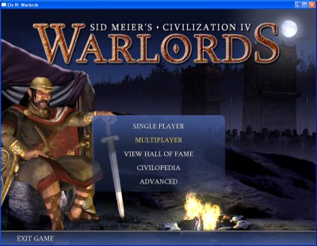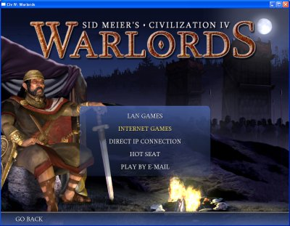

If you have already obtained a Gamespy username through Civ4 (your normal Gamespy username probably won’t work, as this is a separate system; however, you can typically reuse the same username, as I do), then just click “Login” and enter your username and password. Caution: If you misenter any information, you won’t get an error message – you’ll just wait ten seconds or so “frozen” and then come back to the screen, unchanged.

If you don’t have a Gamespy-Civ4 login, then click on “Create New Account”. It requires an email address, a login, and a password- that’s it! Then return to the login menu and log in using that username and password.

Once you get into the lobby, you should see a screen like this:

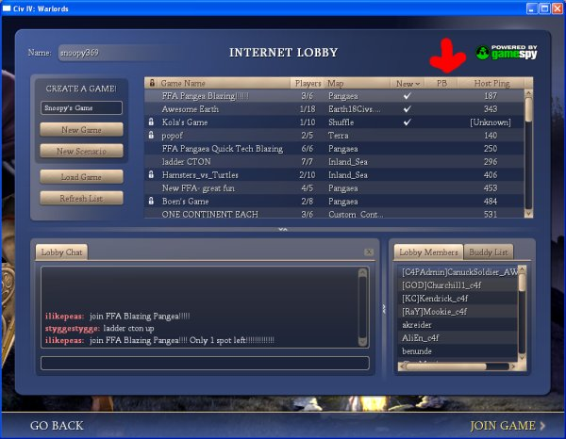

Note the highlighted column. “PB” means, of course, PTBS. Clicking on this sorts the list by PTBS games, which can help in identifying your game.
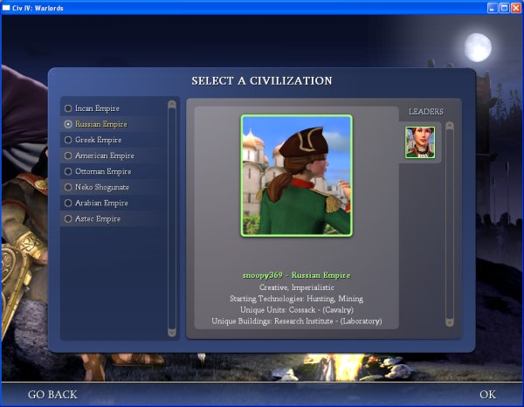
Once you have found your game, select it and either double-click it or click on “Join Game” (highlighted). That will bring up the popup asking for the game password; entering it should bring up a list of the civs playing. Caution: PTBS games have the same firewall restrictions as regular MP games. If you have problems connecting at this point in the game, it may be due to a firewall issue either on your end or another player (or the host).

Select your civ and hit OK. If it’s your first time playing the civ, you will be prompted to enter a password, and confirm it. This is highly recommended, as even an honest player might accidentally misclick and select the wrong civ from time to time. If you have previously entered a password, it will ask you for the password; if you choose to skip the password, it will enter straight into the game. (Alt-D brings up the change details menu if you need to change your password in the future.)

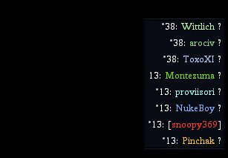
If you’ve gotten this far, you should be in the game itself. Just play your turn, like normal, and then hit Enter (to end turn) or the little red dot that ends your turn. Then, Esc, and Exit to Main Menu (or to Desktop). Unfortunately, it’s not possible to Exit to Gamespy (yet), so if you’re playing several turns in different games, you need to re-log in each time.

Pay attention to the other players in the game, and whether they’ve completed their turns. If you’re the last player on this turn, you get a 2-for-1 and can play your next turn immediately after your current turn! Each player that has completed their turn has an asterisk (“*”) next to their score in the score listing.

Hosting a PTBS game

Hosting a PTBS game is a fairly simple operation, as long as you meet a few simple requirements. You don’t need a particularly powerful computer (On your average Civ4-compatible computer, the PTBS server program takes 2-3% of the CPU, hardly noticeable), you don’t need very much memory (50 MB or so is used on a persistent basis), and you don’t need to download any new software or even make any changes in your firewall that you haven’t already made for Civ4.

You do need a few things, though. First off, you need to have your computer on 24/7, or as close as possible, as any time your computer is off the game is down. Second, you need to make sure your computer doesn’t go to sleep, suspend, or hibernate; this will disconnect the game. Of course, the internet connection also needs to stay alive the entire time and not disconnect, although if you run the server in Gamespy mode (instead of DirectIP) it will maintain a connection with the Gamespy server.

Starting a PTBS game:
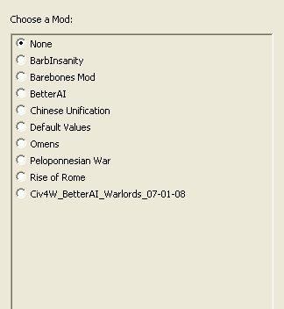
First, run the PTBS server program. It’s located in the \Program Files\Firaxis\Sid Meier’s Civilization 4\ directory (Vanilla), or \SMC4\Warlords (Warlords). (It’s in the same directory as your game EXE.)

It should look like the picture on the right there.

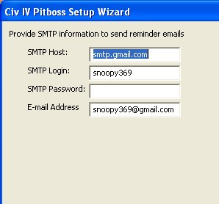
Choose whether you want a mod (like BetterAI) or just to play it as regular warlords/vanilla. Remember that if you choose a mod, every player must load the mod before playing each turn!

Then, if you have information on your email protocol and want to enter it here, do so. Most major email servers don’t seem to work for me – neither gmail nor yahoo do – because they use secure smtp, on a port other than the usual, which this doesn’t support. But feel free to try it ☺ If it works, then your PTBS server will send an email every time a turn starts. Or just use Civ4Stats, which I’ll explain later.

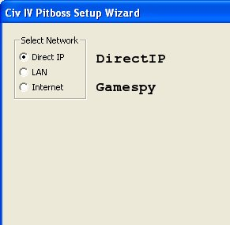
Third, determine if you’re running it in Gamespy or DirectIP. Gamespy goes down every week or so, requiring a game restart, but has the advantage of a consistent address. If you have a static IP, or use dynamic DNS, then DirectIP might be a better choice. Internet = Gamespy, by the way.

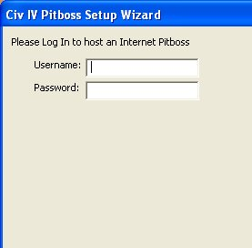
Fourth, if you’re using Gamespy (DirectIP skips this part), enter your username and password. You will need a second username and password for this step if you plan to connect to other games as a player while this is running. Get that second username from in-game (Civ4) just like you got your first one. Also, the username you enter here will become your default username for Civ4/Warlords (whichever you’re running PTBS from). That’s annoying, but can’t be helped. Each time you change it to your Civ4-playing account, it will reset the default to that, so you’ll only have to reenter it once each time you run PTBS.

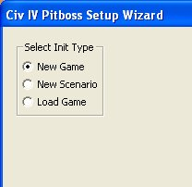
Fifth, of course, you’ll need to tell it whether you’re starting a new game or loading one. You can use scenarios, by the way, if you’re interested in playing that way, but your players will have to load the scenario also. If you’re loading a game, it will just open a browsing window, usually to My Docs or else the last place you loaded a game from; select the correct game, and … you’re off!

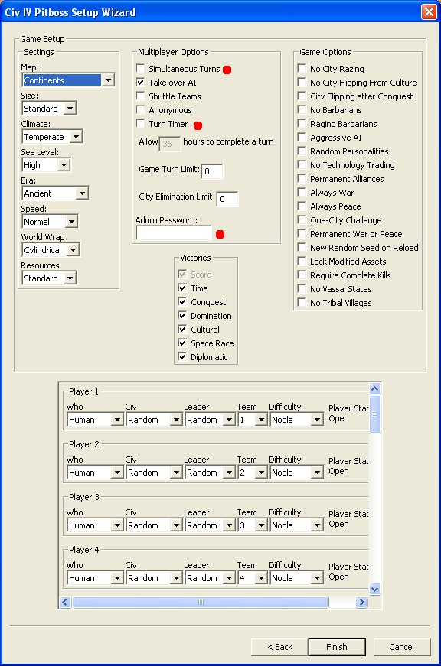
If you’re starting a new game, then it’s a bit different. First, enter a name when it prompts, and a password (this will be the connection password, NOT the admin password; each player needs to enter this to join the game).

See the picture to the left here. All of the options of a normal custom game are present; map options on the left, game options on the right, MP options in the middle. Note the three red circles: These are settings that it’s easy to forget.

1: Simultaneous turns. Most PTBS users will want this checked; this means everyone can play in whatever order they want, instead of one player after the other [pbem-style]. If you want a PBEM style game, leave this blank. In a non-simul turn game, a player can still ‘move ahead’ in that s/he can still plan out his/her moves and set a move/build/tech queue during another player’s turn, so it’s possible to play your turn during another’s turn, but your turn timer would still go its entire length.

2: Turn timer. Check this, or PTBS is basically useless … If you selected Simultaneous turns, this will be the length of time that the entire turn takes (so 36 hours means 36 hours per turn). If you didn’t, this will be the length of time each player has to complete their turn (so 36 hours means in theory 36 hours per player). You can see why most PTBS games are simultaneous :) Of course, the turn will reset when all players have finished their turns, regardless of turn timer (and in non-simul turns, the turn will move to the next player when the current player’s turn is completed).

3: Admin password. Please set this, otherwise your game is not at all secure :) You will only enter it when you load the game (you can’t use it like in PBEM to override someone else’s password).

Once you’re done with settings, you can enter in your civs. You can’t set any info for the civs ahead of time other than leader/civ/difficulty. You need to set difficulty, as far as I know, for ALL civs individually. The first player to enter as any given civ will give it his/her Gamespy name, and can edit settings like passwords and email notification address once he/she has logged in.

Then hit finish and you’re ready to play :)

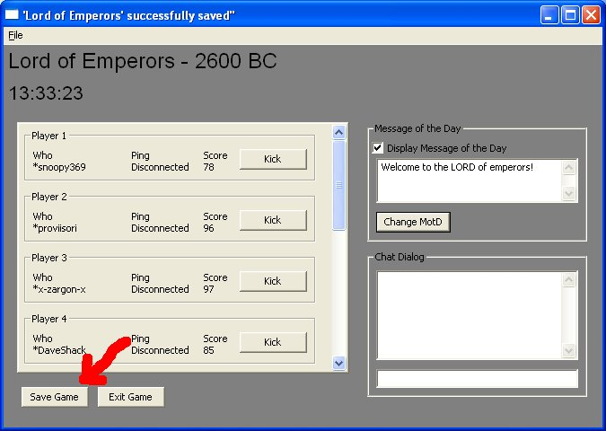
You’ll see a window like this to the right here, which is your game running! Note the red arrow, that’s pointing to the MOST IMPORTANT THING ON THE SCREEN, which is the save game button. Save early and often; it will autosave according to your Civ4.ini or Civ4Warlords.ini file’s specifications (edit this to save every turn, please!!), but it’s highly recommended to manually save when you have an opportunity, as that way you can save the progress of half a turn :)

Also, if the game disconnects from Gamespy (or your internet disconnects), you will need to SAVE THE GAME FIRST before you re-load it. Literally save game, exit, load game.

There may be a bug with saving ‘over’ old game names, so I recommend giving a new name each time you save the game [usually the year changes so it’s not a problem, but if you save it twice in the same year, add an “a” or something at the end].

You can enter a MOTD, that displays to each player when they join!

The * means a player has played his turn already. You can also see players’ ping and their connection status.

That’s it :) Don’t forget to go to www.civstats.com and register your game there so players can see how much time is left and whatnot – you need to run the CivStats Uploader to make this work, it’s all on the website :)

