Folks

After much experimentation I have found out how to get two humans working in a scenario.

The first thing you do is having the scenario I sent in your scenario file.

Before you open the email you need to have a game folder created in you CTP directory for our game such as this one called Patriot: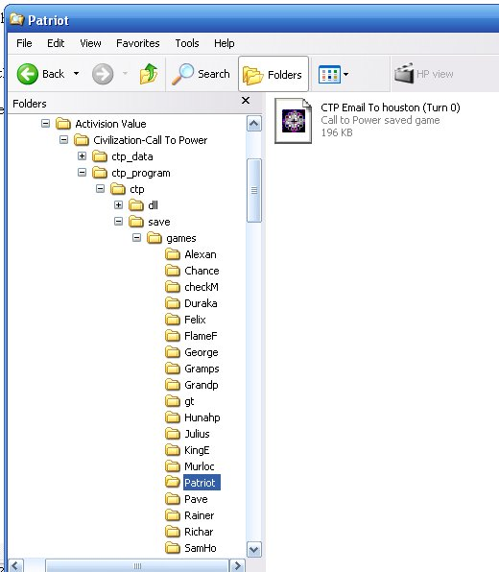

Then when the save comes you need to save it to that folder. Then close out the browser and launch your CTP Disc.

In the main screen click email game like your going to launch a new game:

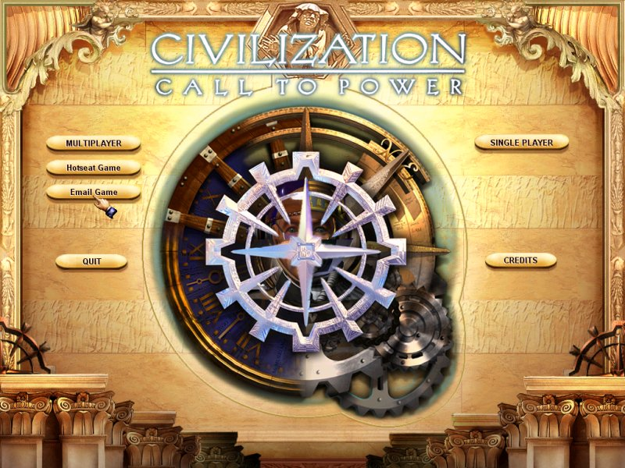

Then select the proper scenario main folder and click ok

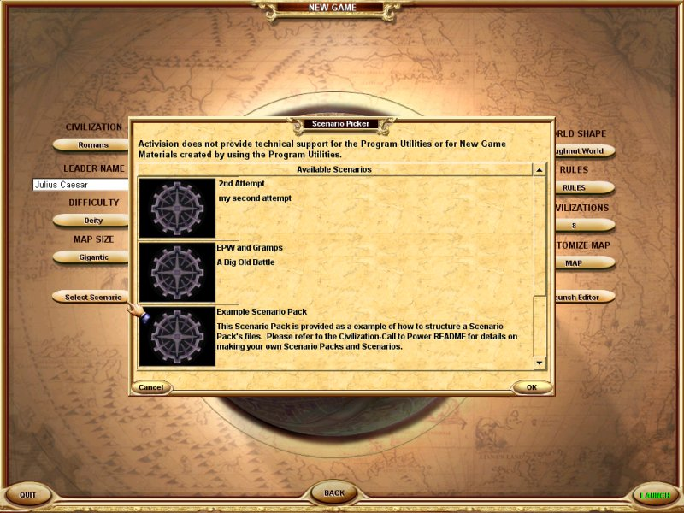

Then the next folder:

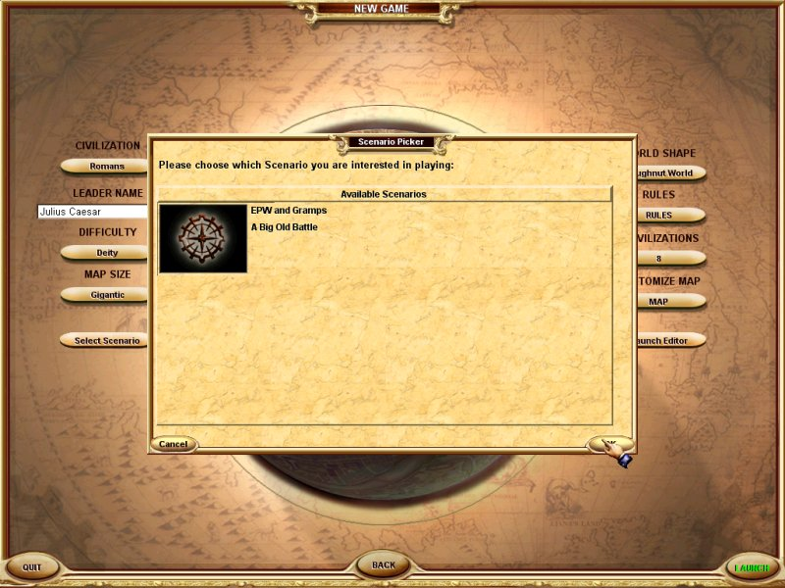

Then in green you should see the scenario on lower left:

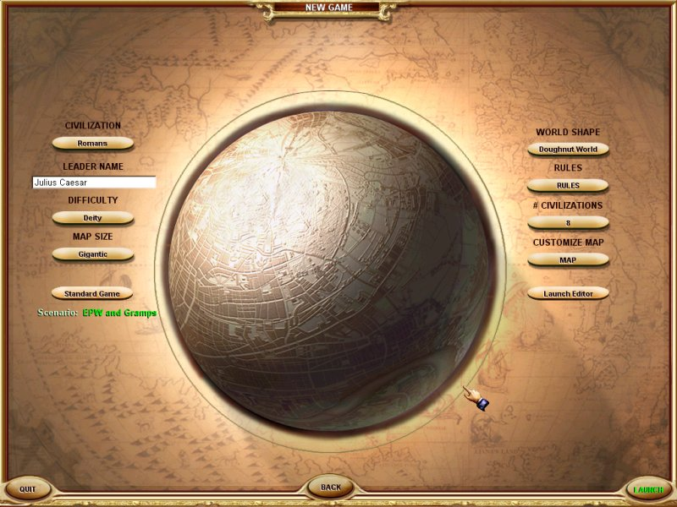

Now click LAUNCH from lower right:

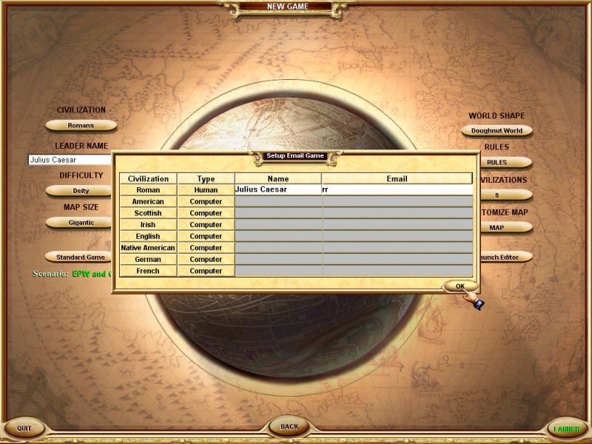

This brings up your normal setup screen, all you need do is launch the game, put it on one human with any name and a couple letters for email address and then PRESS OK:

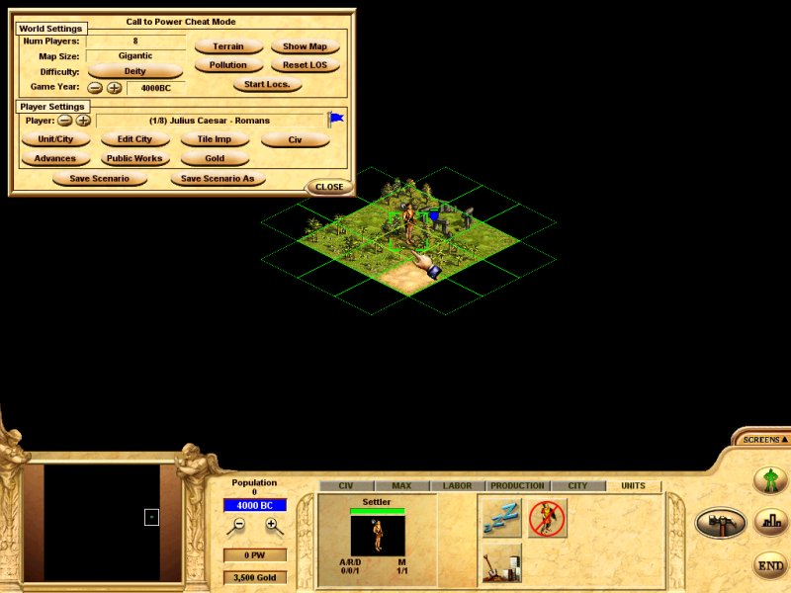

Now your in the start of the scenario, what you have done is loaded the scenario rules for the game to read, this is the step we have been missing, this is a must when you play any scenario, single player or multiplayer, you have to first load the scenario files:

Next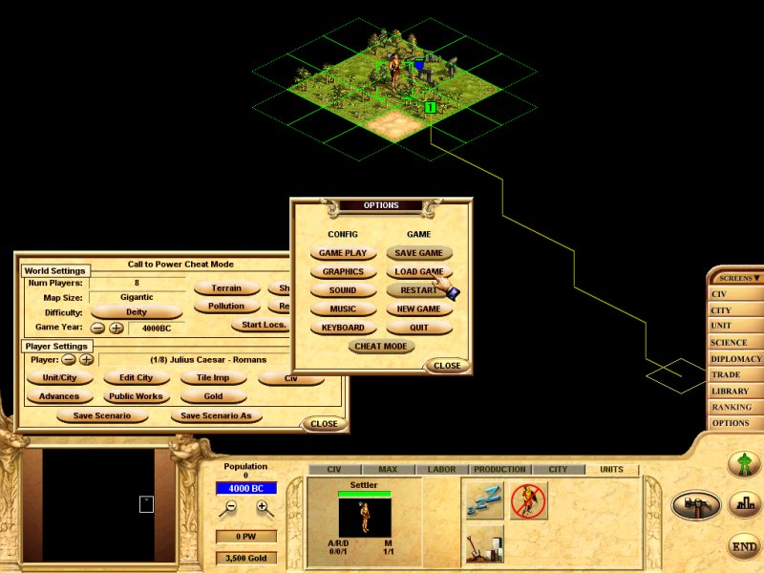

Go to right side and click the SCREENS>>OPTIONS>>LOAD and press LOAD: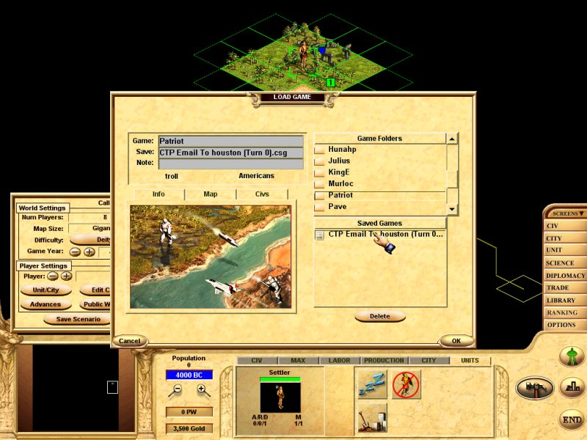

Now highlight the Game folder and press the save you need:

The game now goes on from what a normal PBEM does

Send the next save to the person your playing with and they repeat the process

What we have is very similar to playing CIVIII where as you have to save the email to a folder then launch the game and play the save and then save the file to an outgoing folder, but in CTP it will go to your desktop.

I’m pumped and hope this will encourage you

Not but probably an extra 1 minute or so to do this

Looking forward

Gramps

