Queen wins Summernats Burnout Comp in blown Holden Ute
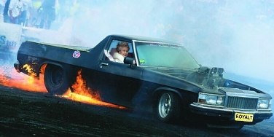
Canberra, January: Her Royal Highness stunned judges and wowed the crowd on her way to winning the Summernats Burnout Title in a supercharged Holden Ute. In a three minute display of tyre-shredding aggression the Queen completed six donuts and four figure eight's before blowing both rear tyres. The Queen, a self-confessed Holden nut, did most of the mechanical work on the stroked and blown 308 engine that powered her to victory.
A Summernats Burnout judge described her run as being "exceptional, especially considering she was holding a stubbie in her left hand during the run. And I'm buggered to know how she got her arse out the window during that donut."
"We are fucking stoked" commented the Queen after showing the first prize trophy to the cheering crowd.
Future plans for the ute include a green and gold paint job, and a rear restraint for her Blue Heeler 'Bluey', who fell out and was run over during the first donut.

Queen hits 738 in backyard cricket match
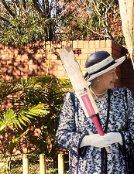
Newcastle, February: A backyard cricket game turned into a beer-fuelled slog-a-thon when the Queen smashed a massive 738 runs in a marathon 19 hour innings that neighbours described as "bloody noisy".
The Queen took to the crease shortly after her 4th beer at 8am, and batted through until 3am the following morning showing form that onlookers likened to "a pissed Bradman". The backyard, littered with empty VB cans, came into it's own midway through the afternoon with the introduction of the "Hit a can, Skull a can" rule. But the extra alcohol did not dent the Queen's concentration, says Johnno: "The more she drank the straighter she played. The beer just made her better."
Johnno, who had smoked cones in the afternoon drinks break, admitted to not helping the cause by bowling 47 wides in a single over.
The match, extended into the night by backyard floodlights, finally ended in controversial circumstances when Johnno, unable to locate the ball, bowled the sack from a wine cask and took out middle stump. David Boon described the innings as "fucking tops".

Queen's Victa won't start after 44 attempts.
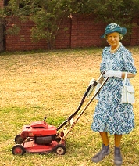
Saturday, 9am: The Queen utilised most of the profanities in the Queen's English and even invented some new ones after 44 futile attempts to start her Victa.
"Fucking mongrel bastard!" said the Queen, pulling the starter cord.
"Fucking bloody dogturd thing!"
"Donkey-fucked bitch-slut machine!"
"Useless piece of shitfuck dickswallowing lawnmower!"
"Fucking bloody FUCK-FUCK!"
The Queen kicked the Victa and stormed off in disgust. Three hours later, when she had calmed down enough to give it another go, the Victa started perfectly on the first pull.
"That'd be fucking right" she said.

Queen's old fridge reborn as Beerfridge.
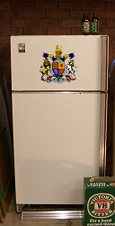
Saturday, 1pm: Following the purchase of a new Kelvinator, the Queen's old Kelvinator was relocated to the garage and renamed "The Beerfridge" in a solemn ceremony attended by two of the Queen's mates.
The ritual moving of the fridge was performed smoothly, except for Bluey the mongrel dog chewing on Johnno's shoe during a heavy lift. Once in the garage, Her Majesty turfed the vege crisper drawers into the whizbin to make more room for tinnies.
"We are pleased to open this Beerfridge" announced the Queen as she cut the ribbon. "May it keep our VBs cold, seal poorly and grow a massive iceberg in the freezer".
"It's a beautiful thing" said Johnno.
Royal sources say the Queen plans to have a case of VB in the fridge for most of the year, except during Christmas when she will shove 600 tinnies, a kilo of prawns and a ham into the bastard.

Queen gets pissed and puts shit on New Zealanders.
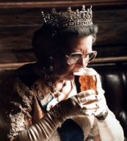
Bondi, Saturday, 11pm: Punters at the Bondi Hotel were stunned on Saturday night after overhearing the Queen putting shit on a group of New Zealand backpackers.
"Ya shhtupid fuskin ssheep-rooterers" commented the Queen after one of the tourists spilt her 12th schooner. "None of youse can plaay cricket for sssssshit. And youse shhtink at footy, too, don't yasss. eh? eh? eh? yess yas do... eh? Shhtupid New Fucksing Zealandernessses. Why don't youse all sscare me with a haka dansce? hey? ..... kiwi poofs."
Following the incident, New Zealand's Prime Minister considered declaring war on Australia, but decided not to after realising that New Zealand would lose because New Zealand is crap at everything.

Queen tells mongrel to shuuuudup.
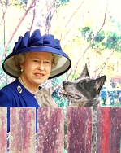
Sunday, 8am: During a morning chat over her backyard fence to her next door neighbour, the Her Majesty was overheard telling her dog to "shuuuuuuudup ya bloody mongrel!". This news comes just days after the Queen was heard instructing her dog to "giddddown off me frock, you fucking stupid dog!"
Royal sources tell how the Queen's Blue Heeler, 'Bluey', is typically a well behaved dog, but occasionally becomes a fucking little bastard mongrel. This was confirmed later in the day, when a bored Bluey dug up the Queen's favourite azaleas and did a shit on the driveway.

Queen warned to cut booze, fags.
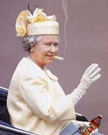
Tuesday 10am: "Cut the smokes, cut the booze, and lose the beergut."
This was the advice given to Queen Elizabeth II during her recent visit to the doctor. The GP told Her Majesty that a change of lifestyle was needed if she still wanted to be Queen in 2010. After hearing of her 4 pack a day habit and weekly consumption of 8 cases of VB, the doctor said she was in the "extremely high risk" category. He then paused and added "I don't know how it is you are still alive".
The Queen, who drank from a longneck and chain smoked throughout the checkup, asked how the hell she could possibly give up nicotine and VB- her main reasons for living. "We'd feel fucking stupid watching the footy without a beer or a smoke. But We suppose We should give it a go".

Queen's Whizbin gets flogged.
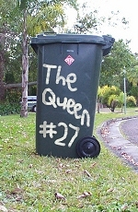
Wednesday 9am: Queen Elizabeth II was said to be most upset after discovering that her whizbin had been flogged in the early hours of Wednesday morning.
The Queen, who is always the first on her street to put the bin out on bin night, said she didn't know who the hell would want to steal her wheelie bin, as it had her name on it, and smelt like shit anyway.
Upon hearing of the incident, Prime Minister John Howard decided to personally head the investigation, allocating resources from Federal and local Police, ASIO, the Army Reserve and the Rotary Club of Warnambool to investigate the crime. Authorities currently suspect an international mafia crime syndicate, or kids, to be responsible for the theft.
Have you found the Queen's Whizbin?
Send your photos to topaussiesNO@SPAMhotmail.com

Queen banned from Melbourne Cricket Ground.
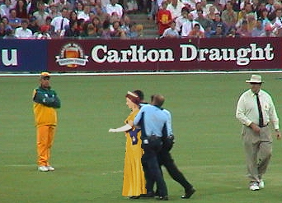
Melbourne, Friday 9pm: Her Majesty was escorted from the MCG by Victorian Police on Friday night, accompanied by crowd chants of "The Queen's going home in the back of a divvy van, Long Live the Queen".
Witnesses from Bay 13 told how the Queen "drank like a fitter" and "swore like two fitters" during Australia's demolition of the English one day side, who were totally and completely shithouse. She then ran onto the field and attempted to grab an English batsmen's cricket bat, shouting "The Royal arse could play better than you Poms!", before being crash tackled by Security and led off the field.
Later, a Police Sergeant told how the Queen was "The drunkest human ever held in custody in Victoria. She threw up about a hundred times all over the station floor. She probably shouldn't have eaten those chicken kebabs either."
The Queen was released Saturday morning after being fined $1000 and officially cautioned about future consumption of chicken kebabs.

Queen Farts and Laughs.
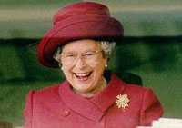
Monday, 4pm: The Queen was observed laughing loudly and fanning air away from herself after inadvertently letting a massive fart rip out.
"We are glad that's out" said Her Majesty, before laughing again and shaking her head.
"Well spoken!" said her mate Johnno, who was nearby.
"Fuck me, that's rotten" Johnno added a short time later.
Royal insiders told how the Queen often farts, especially after a meal of Heinz Chilli Beans, but said she usually blamed it on the dog.
"Christ, that had staying power" said Johnno, 10 minutes after the incident.
The Queen later refuted an allegation from Johnno that something had crawled up her arse and died.

