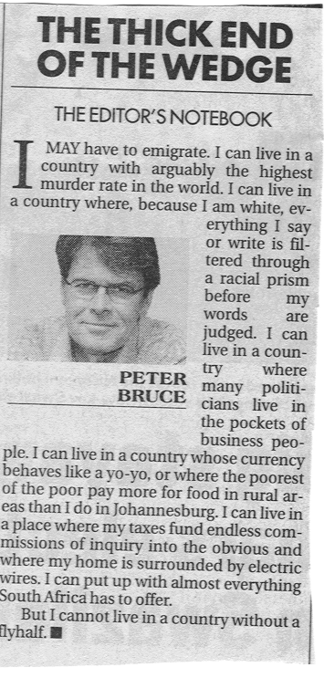
SA vs ENGLAND

The definitive comment from Business Day on 20 October 2003

