Pravda
June 1941 Issue 1

Field Marshal Klesh Dies in freak Accident.
(RP) The Marshal of the Soviet Union died yesterday in an accident during an inspection of the 173rd Cavalry battalion stationed outside Moscow. While inspecting the equipment of one of the mounted troopers, a mouse frightened the horse and caused it knock over Marshal Klesh and then proceeded to trample him to death before the beast could be brought back under control. Funeral plans are being made, it is expected that Marshal Klesh will be laid to rest in his native Ukraine from which he came.

The newly elected Ministers moved into their offices this week (RP), and began making inspired changes to their respective ministries. Word coming from the office of the Economic Minister has it that sweeping changes will soon be coming out to adjust the already booming economy and send it to new heights. Meanwhile in the Propaganda Minister’s office, plans are being made to record the glorious achievements of the Rodina.

War in Africa. (RP) The war in Africa continues to go well for our German neighbors, just last month General Erwin Rommel captured Tobruk and received promotion to the rank of Field Marshal for his service against the British.

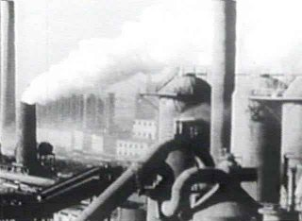
(The great automobile factory in Kharkov produces 1500 cars and trucks per shift and works 3 shifts)

Henrikov ascends to the rank of Marshal of the Soviet Union.
(RP) Following the demise of Marshal Klesh, General Henrikov has been promoted to the rank of Marshal and given command of all Soviet forces. He is expected to name his commanders shortly.

Spies and saboteurs are everywhere. (RP) Upon investigation into the bad crop harvest in and around Minsk. It appears that someone has been salting the soil of the local kolectivs. Investigators from the local office of the Shield of the Party have received tips on the identity of the person who would attempt to starve our workers paradise. If you see suspicious behavior by anyone, contact the police immediately. Do not let the capitalists win!

