SK138’s PTW Extra Units List V1.0

READ: I created a scenario and used the TETurkan scenario to help me determine what units go to what icon. If you make any changes to this file, please credit me, SK138, to the original creation and also email me a copy at SK138@adelphia.net.

READ: I am looking for any more information about any of these units, especially the Medieval Japanese ones. If you have any information for the civilopedia, unit functions, or where the unit could replace a different unit, please email me at SK138@adelphia.net.

Medieval Japan

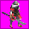 Warrior Monk
Icon: 138

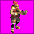 Stone Crossbow
Icon: 137

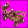 Siege Crossbow
Icon: 136

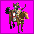 Shoni no Kagesuke
Icon: 135

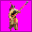 Otomo Spearman
Icon: 134

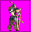 Otomo no Makuta
Icon: 133

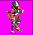 Oda Arquebusier
Icon: 132

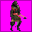 Ninja
Icon: 131

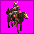 Nakamaro Horseman
Icon: 130

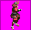 Minamoto Samurai
Icon: 129

 Medieval Japanese Worker
Icon: 128

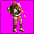 Medieval Japanese Settler
Icon: 127

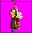 Medieval Japanese Leader
Icon: 126
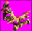 Medieval Japanese Catapult
Icon: 125

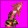 Medieval Japanese Army
Icon: 124

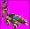 Fire Cannon
Icon: 123

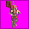 Ashigaru Spearman
Icon: 122

World War II

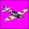 Zero
Icon: 151
Country: Japan
Replace: Fighter

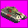 Tiger II
Icon: 159
Country: Germany
Replace: Panzar

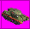 T-34
Icon: 81
Country: Russia
Replace: Tank

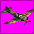 Sturmovick
Icon: 157
Country: Russia
Replace: Fighter

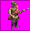 Russian Rifleman
Icon: 88
Country: Russia
Replace: Infantry

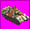 Panther
Icon: 161
Country: Germany
Replace: Panzar

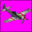 P-51 Mustang
Icon: 156
Country: America
Replace: Fighter

 P-38 Lightning
Icon: 155
Country: America
Replace: Fighter

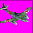 ME262
Icon: 154
Country: Germany
Replace: Figher

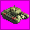 M26 Pershing
Icon: 160
Country: America
Replace: Tank

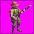 Japanese Rifleman
Icon: 89
Country: Japan
Replace: Infantry

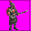 Italian Rifleman
Icon: 91
Country: Rome, Carthage, Ottomans, and Greece
Replace: Infantry

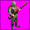 German Rifleman
Icon: 83
Country: Germany
Replace: Infantry

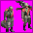 German Heavy Machinegunner
Icon: 94
Country: Germany

 German Flamethrower
Icon: 86
Country: Germany

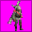 German Anti-Tank
Icon: 95
Country: Germany

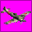 FW190
Icon: 153
Country: Germany
Replace: Fighter

 F4F Wildcat
Icon: 152
Country: America
Replace: Fighter

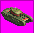 Churchill
Icon: 158
Country: England
Replace: Tank

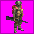 British Rifleman
Icon: 90
Country: England
Replace: Infantry

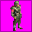 American Rifleman
Icon: 87
Country: America
Replace: Infantry

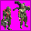 American Heavy Machinegunner
Icon: 93
Country: America

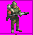 American Flamethrower
Icon: 92
Country: America

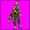 American Anti-Tank
Icon: 96
Country: America

Prehistoric

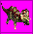 Triceratops
Icon: 150

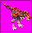 T-Rex
Icon: 149

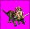 Torosaur
Icon: 148

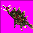 Stegosaur
Icon: 147

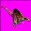 Spinosaur
Icon: 146

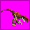 Raptor
Icon: 145

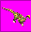 Plateosaur
Icon: 144

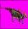 Parasaur
Icon: 143

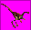 Gallimus
Icon: 142

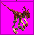 Deinoychus
Icon: 141

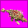 Anklyosaur
Icon: 140

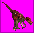 Allosaur
Icon: 139

I created a scenario and used the TETurkan scenario to help me determine what units go to what icon. If you make any changes to this file, please credit me, SK138, to the original creation and also email me a copy at SK138@adelphia.net.

I am looking for any more information about any of these units, especially the Medieval Japanese ones. If you have any information for the civilopedia, unit functions, or where the unit could replace a different unit, please email me at SK138@adelphia.net.

